Documentation — Group 22, Quick-Response Subcontracting Desk
Nov 5, 2026 · @kailing

1. Team information
Group 22, DSS5105 Capstone, Track 2: the Quick-Response Subcontracting Desk.
- Code: github.com/kailinghew/DSS5105_Project (public)
- Live demo: qr-subcontracting-desk.onrender.com (free tier: the first visit after 15 idle minutes takes about a minute to wake)
Member | Student ID | Role | Main contributions (from the commit history)
Hew Kai Ling | A0126573A | A: intake agent, build and deployment | Tool layer, allocator and objectives, Claude parser and validation, router and replies, audit log, web app, Render deployment, inbox scorer, held-out run, failure-case fixes and CI
Ge Yuzi | A0357013M | B: evaluation lead; allocator experiments | Blind re-check of the 30 labels, frozen held-out set, stricter number-trace check, failure log; defects within the lateness guardrail (reserve-fast-shops policy) and the hybrid weight comparison (`eval/c2_experiments.py`, `eval/c3_experiments.py`)
Wang Tianyi | A0352652E |  | Delivery estimates checked against the simulator; tool specification (docs/tool_spec.md)
Zhang Mingxuan | A0352498N |  | To be filled in
Contribution percentages and collaboration are in Teams.pdf.

2. Problem statement
When SweaterCo's factory is full, a dispatcher farms batches out to eight subcontracting workshops, and today that decision is one line in a group chat with no record of why. We built a desk that reads the chat request, checks every workshop, recommends one with its reasons, and asks, refuses or says "impossible" instead of guessing.
The user. The dispatcher, who receives one-line requests from the boss and the planners ("ORD-017, 800 cardigans for TrendCart, back by Apr 10"). For each batch they must check three things across all eight workshops: can it make this product, can it take the work now (queue and capacity cap), and is it allowed to (suspended shops). A wrong pick is found a day later, in a production cycle of 7 to 14 days, and the reasoning is in one person's head.
The data. 120 orders (orders.csv), eight workshop profiles (workshops.csv: what each makes, capacity per day, current queue, defect rate, cost per piece, pickup lead time, batch cap, status), and 30 chat requests from one morning (dispatch_requests.txt).
Why existing approaches fall short:
Approach | What it gets right | Where it fails
The dispatcher's memory and the chat | Fast, knows the people | No record, no consistency; misses caps and suspensions under pressure
A spreadsheet of workshops | Holds the facts | Cannot read a chat message; the dispatcher still does every check by hand
A general chatbot | Reads any wording | Invents queue lengths, dates and costs; cannot be audited; arithmetic by LLM is the main source of wrong answers
A fixed allocation rule (e.g. earliest finish) | Good, repeatable picks | Cannot read a message, notice a missing date, refuse an ineligible shop or explain itself
The desk keeps what each does well: the rule's arithmetic, done by deterministic tools; the chatbot's reading, limited to extracting fields; and a record of every decision.

3. System architecture
The language model has one job, turning a chat message into fields, and everything that decides or computes is plain Python. That split is the main design decision: the model can be wrong about wording, but it can never invent a date, a queue or a cost.
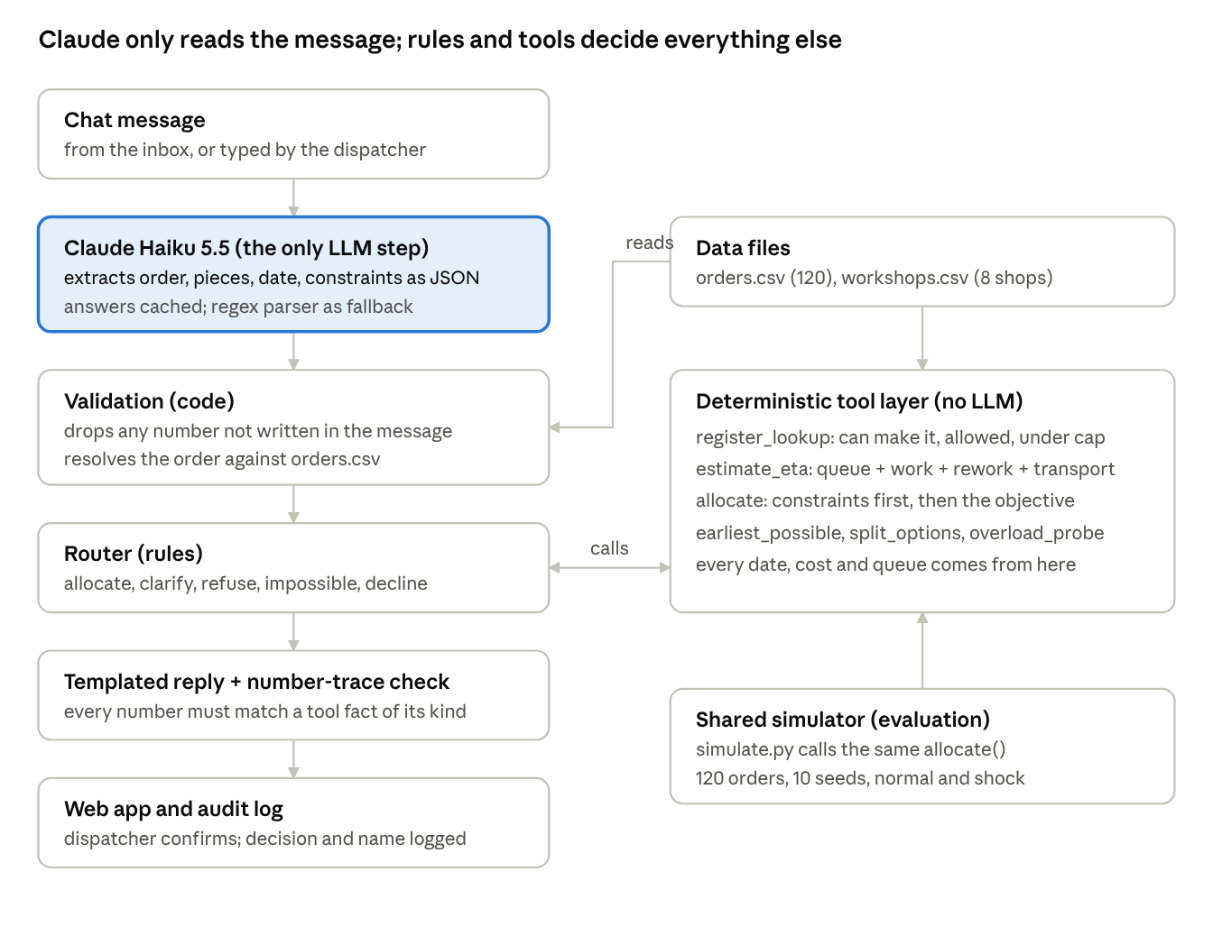
System architecture as built · the pipeline on the left, the shared tools on the right
Data flow for one request.
- Read. The message goes to Claude Haiku 5.5 with a JSON schema; the API forces the reply to match it (order id, pieces, due date, customer, product, suggested workshop, constraints, what the sender says is missing, question type).
- Validate. Code checks every extracted value against the message text and drops any number that is not in it. It then resolves the order: an explicit id is looked up; a customer or product name returns the matching open orders; values the message does not state are filled from orders.csv.
- Route. Rules choose one of five behaviours, checked in this order: decline if the question is about history, prices or an unknown order; clarify if something the sender called unknown is missing or the order is unclear; refuse if the suggested workshop is ineligible; impossible if no workshop can make the date; otherwise allocate.
- Compute. The router calls the tool layer, which returns every candidate workshop with its eligibility, ETA, cost and defect rate, and ranks them under the configured objective after applying the sender's constraints.
- Reply and check. A template writes the reply from the tool facts. The number-trace check, run on every reply in evaluation, confirms each number matches a fact of the same kind.
- Confirm. The dispatcher confirms in the web app, and the decision, its reasons and the confirmer's name are appended to the audit log.
One allocator, two uses. The simulator policy in desk/allocator.py calls the same allocate() as the live desk, with the simulator's queues in place of today's. So the simulator results describe the policy the dispatcher actually gets. The two queue dates are kept apart on purpose: the inbox uses the 1 April queues, the replay starts from 1 January.

4. Technical stack
We chose the smallest stack that does the job: one model call per message, plain Python with the standard library, and one external dependency (anthropic). Each choice below was weighed against an alternative we rejected.
Layer | We chose | Instead of | Why
Language model | Claude Haiku 5.5 (claude-haiku-5-5), structured JSON output | Claude Sonnet 5.5; no LLM | Extraction is a small task: 30 of 30 on the development set and 30 of 30 behaviours held out, about 5 s and 2,200 input tokens per new message. The regex parser stays as the no-LLM baseline and fallback.
LLM role | Extract fields only; Python rules decide | An agent that picks and calls tools itself | No arithmetic in the model, the same message always gets the same decision, and every number can be traced to a tool.
Data access | Direct lookups in three small CSV files | A SQL database or a vector index | 120 orders and 8 workshops fit in memory; an exact lookup cannot retrieve the wrong row.
Reproducibility | A committed cache of every Claude answer | Setting temperature to 0 | Haiku 5.5 does not accept a temperature setting, so caching is what makes runs repeat exactly and lets anyone rerun the evaluation without a key.
Records | Append-only JSONL audit log | A database | Readable line by line; one file per deployment.
Web app | Our own page on Python's built-in HTTP server, plain JavaScript | Streamlit | Full control of the layout, no build step, no extra dependency; Streamlit was also blocked in our build environment.
Hosting | Render free tier, from render.yaml | Hugging Face Spaces | Hugging Face Docker Spaces need a paid plan. Render is free but sleeps when idle and has no persistent disk.
Testing | pytest, 27 tests, no API key needed | Manual checks | Tests fake the API, so the parser, router, server and trace check run on every machine.

5. Features and capabilities
The desk handles every kind of request in the course inbox with one of five behaviours, and never allocates on a guess.
Behaviour | When | Example from the inbox | What the desk replies
Allocate | Order, quantity and date are known and a workshop can make it | R21: cheapest shop that can still make Apr 13 | GiantWeave: ready about Apr 12, $1.10 a piece, "honoured Chen's instruction (cheapest)"
Clarify | The sender says a value is unknown, or several orders match | R03: "Can we get the TrendCart order moving?" | Lists the 6 matching TrendCart orders and asks which; will not allocate until told
Refuse | The suggested workshop cannot take it | R11: give ORD-008 to OldMill | OldMill is suspended; suggests Nimble Needle, on time for Apr 9
Impossible | No workshop can make the date | R20: 2,000 scarves due Apr 4 | Earliest single shop is SteadyHands, Apr 17; options: accept lateness, split (still late), escalate
Decline | The data cannot answer it | R02: which workshop did we use for Harbor Knits last October? | Says the system holds no history of past allocations
Implementation insights.
- Constraints from the sender win over the objective. "Not QuickStitch", "fastest", "cheapest that is still on time", "lowest defect that is still on time" and "split is fine" are extracted as typed constraints, each with who imposed it. allocate() applies them first, then lets the objective choose among what is left; the reply names whose instruction it followed.
- The objective is configuration. Five weightings of lateness, defect rate, load share and cost live in config/objectives.json (lateness is primary). Criteria are min-max normalised across the candidates, so a weight means the same thing on every request.
- Invented numbers are dropped, not trusted. Any order id, quantity or date in Claude's output that is not written in the message is removed with a warning and then filled from the order record or asked for.
- Graceful fallback. With no API key or no network, the desk uses the regex parser and says so on every request; the evaluation flags it.
- Explanations from facts. Replies are templates filled from tool outputs, and the number-trace check matches every number to a fact of its kind (a date to an ETA, $ to a cost, % to a defect rate).
The dispatcher's screen.
- Requests: the morning's chat on the left; pick or type a message to see the verdict, the key numbers, whose instructions were followed, and a strip per workshop showing queue wait, making time, expected rework and transport against the due date, so the winner's lead is visible.
- Read all: triages the whole inbox at once.
- Confirm and log: writes the decision with the confirmer's name; "Copy reply" gives the text to paste back into the chat.
- Workshops: answers "who can take N pieces by date X?" across all eight shops, with their profile cards.
- Decision log (newest first) and settings for the objective and the parser.
- Safeguards on the public link: the API key stays on the server, messages are capped at 500 characters, and Claude calls at 200 an hour.

6. Challenges and limitations
The biggest open weakness is wording the parsers were not built for: the regex baseline silently sends batches to shops the sender ruled out ("steer clear of", "skip"), and Claude's held-out misses come from our own validation code. All 15 analysed failures are in Evaluation.pdf; the main ones and their mitigations:
Limitation | Effect | Mitigation now | Next step
Regex parser misses unseen wording (F1 to F9) | Wrong shop or an allocation that should have been a question, with no warning | Claude is the web app's default parser; regex is the fallback and baseline | Wider cue lists with a test per cue; score Claude on the same probes
Product-only reference (F10, held out) | Desk asks which order but lists none | Behaviour is still right: it asks | Explicit new_order flag instead of inferring it from "order missing"
Defects objective breaks lateness (F12) | 72% of batches late | Lateness is the primary objective; hybrid gives a middle point | Choose the defect weight from a sweep with a lateness guardrail
Claude cannot be fixed to one answer | A fresh call may read a message differently | Every answer is cached and committed | Measure how often a fresh call changes a decision
Splits exist only in the chat layer | Split proposals are not tested by the simulator, which never splits | Splits are judged on the inbox only | Simulate splits if the harness adds them
Free hosting | The demo sleeps after 15 idle minutes; the audit log is wiped on restart | Wake it before a demo; run locally for a lasting log | A persistent disk or a hosted database
Queues are a snapshot | ETAs use the 1 April queue; the desk does not update queues after a confirmed allocation | overload_probe shows how much a batch adds to a queue | Update queues from the audit log
Challenges we hit while building.
- The first schema was rejected by the API. A nullable enum for the question type failed validation; we made it a plain string and check the allowed values in code (test pinned).
- One prompt word cost four requests. Defining "missing" as "needed but absent" made Claude ask instead of refusing (26 of 30). Narrowing it fixed all four, and we logged the change rather than quietly re-running.
- A cleverer allocator was worse. A stall detector for closed workshops raised lateness from 1.7% to 3.8%. We kept the simple rule and reported the experiment.
- The trace check was too loose. It accepted "Apr 8" because the number 8 appeared elsewhere in the facts; it now matches numbers by kind.
- Two queue dates in one file. The same queue column means 1 April for the inbox and 1 January for the simulator. A mix-up would shift every quoted date, so the two paths are kept separate and a test pins a 1 April estimate.

7. References
Reference | How it contributed
DSS5105 Capstone Project Specification v5 | Defined the Track 2 evaluation minimum (all 30 requests by behaviour, decision and explanation; primary, other and hybrid objectives against three baselines with a shock run) and the rule that an LLM must not do arithmetic a tool should do, which shaped our extract-only design.
Track 2 course folder: primer, data_dictionary.md, the four data files | The seven request kinds and their counts, which our gold labels match; the meaning of each workshop column; the 1 April queue date for the inbox.
track2/harness/simulate.py v3 and its three baselines | The shared replay we report against; its eligibility rule is reused in desk/data.py, and its note on queue dates led to keeping the inbox and simulator queues apart.
Claude API documentation | Structured JSON outputs, the effort setting, and the Haiku 5.5 model limits (no temperature), which led to the response cache.
Render documentation | Blueprint deployment from render.yaml, free-tier sleep and the lack of a persistent disk.
Open question for the team: add any papers, posts or repositories each of you used (for example on LLM tool use or evaluation), with one line on how each changed the work.

8. Conclusion
We built and deployed a desk that turns a dispatcher's chat message into a checked, explained and logged workshop decision, and that asks, refuses or says "impossible" rather than guess. It takes the right action on all 30 held-out requests, gets the details right on 28, and is late on 1.7% of batches in the shared simulator against 34% for random.
Lessons.
- Give the model the smallest job. Limiting Claude to extraction meant one prompt change was enough to reach 30 of 30, and no reply can contain an invented number.
- A simple rule is a hard baseline. Our earliest-finish rule ties our primary objective, a stall detector and a defect tie-break did worse, and only reserving the two fast shops for urgent orders improved on it (fewer late days, defects and cost at the same lateness). Most of the system's value is in reading, refusing, asking and explaining, not in a better pick.
- Freeze the test before you look. Writing the held-out set before the final run, and accepting 28 of 30, gave a number we can defend.
- Silent errors are the ones that matter. The worst failures we found are confident wrong allocations, not wrong questions.
Future work. Fix the logged parser failures and score Claude on the same probes; replace the inferred "new order" with an explicit flag; bring the reserve-fast-shops policy into the live desk and choose a defects weighting from a full sweep; test on real, outside-written chat messages; keep the audit log and live queues in a database so confirmed allocations update the next estimate.

